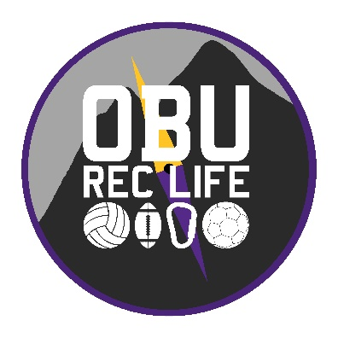
Indoor Climbing Center
Name:_______________________________________________________________

Email: __________________________________________

Cell Phone:________________________

PART I: AGREEMENT TO PARTICIPATE AND HOLD HARMLESS
In agreeing to participate in the Indoor Climbing Center I realize certain risks and dangers exist. These risks include but are not limited to loss or damage to personal property, injury or fatality.

I understand that Ouachita Baptist University’s Board of Trustees, faculty, staff, agents, and other program participants shall assume no responsibility or liability for me for accident, illness, injury or loss or damage of personal property caused either by negligence or risks inherent in the Climbing Center activities. I acknowledge and assume all risks in connection with activities including any pre and post activities and I hold the above mentioned individuals and groups harmless from any and all liability, action, claim, and damage of every kind.

Furthermore, I hereby grant permission to all of the foregoing to use any photographs, motion pictures, recordings, or any other recorded of this event for any legitimate purpose.

PART II: AUTHORIZATION FOR EMERGENCY MEDICAL CARE
I am aware of my general condition and affirm that I am fit to participate in any activities I will engage in at the Indoor Climbing Center. Further, I will fully disclose any relevant medical information to the activity leader/sponsor. In the event I am rendered unable to communicate by emergency or accident, I authorize and request such medical and surgical services as may be necessary, and further agree to accept financial for same.

PART III: MEDICAL INFORMATION
Participation in the Indoor Climbing Center may involve strenuous physical activity. If you have questions regarding your health and participation, please consult your personal physician, and discuss your concerns with the activity leader(s).

My signature on this document is also intended to bind my heirs, representatives, executors or administrators.

PARTICIPANT NAME:__________________________________________________________________

PARTICIPANT OR GUARDIAN SIGNATURE:_____________________________________________

DATE:_________________________

