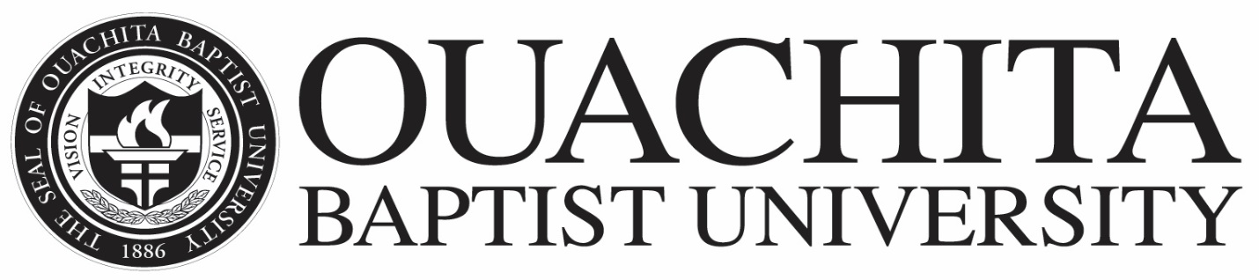

CHURCH MATCHING CERTIFICATION FORM
2020-21

Church matching grants up to $500 per student are provided by Ouachita Baptist University to any Southern Baptist affiliated church choosing to participate. Only students accepted for admission to the university will be considered.

This certification form can be completed and submitted along with the scholarship funds to Ouachita’s Student Financial Services Office, OBU Box 3774, Arkadelphia, AR 71998-0001. Please complete a separate form for each individual student if you are sending funds for multiple students.

It is the intent of the university that the funds for churches participating in this program originate within a church scholarship fund and not from a personal donation by the parent or other family member.

Student Information

Name __________________________________ OBU ID __________
Street Address ______________________________________________
City________________________ State__________ Zip___________

***********************************************

Church Data

Church Name_______________________ Amount Enclosed_________
Street Address_______________________________________________
City________________________ State__________ Zip___________

